***Facts & Curious***

Facts & Curious is a program that will allow users to test their own knowledge about specific, general, and fun topics, while providing opportunities for them to learn useful and random interesting material. It serves as a way for users to have fun learning, pass time, and be self aware of the extent of their own knowledge, that may hopefully encourage users to learn more of the unknown. This program will provide options on what type of questioning methods and topics that the user may want to take on, and provides questionnaires on based on these basis. It will be displayed as a simple user friendly input system that allows users to understand what is being asked, and enter simple answers such as true/false, multiple choice options, and more.

*Demo/Prototype Display*

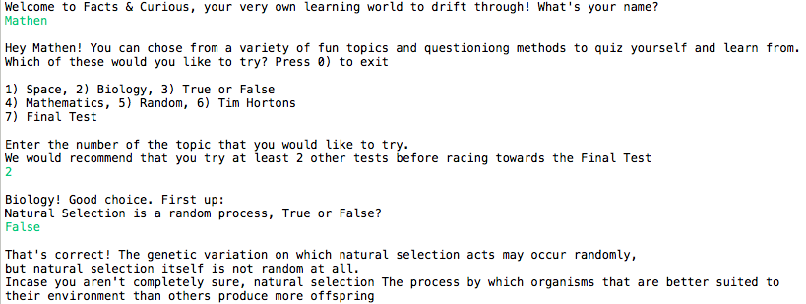

Intro to explain to user about program purpose, instructions and options available.

User input and recommendation that will allow user to be successful.

True or False question and brief info section that will allow user to learn more about topic.

1)

1)

2)

2)

3)

3)

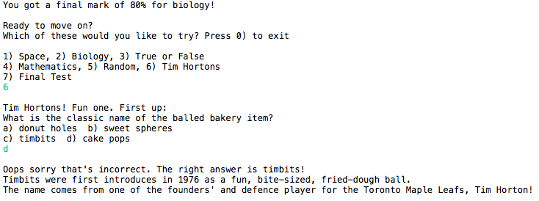

Gives a final mark after completing all the questions.

Prompts user to pick another topic if interested. New multiple choice questioning method introduced.

Informs user about which of the options were correct and once again provides information for users learning experience.

2)

2)

1)

3)

3)

1)

*Methods used:*

1. public static void main(String[]args)

* Method used to run application

1. public static int space(int ques&info)

* Method used to ask questions about space
* Returns int in order to calculate mark percentage
* Needs an int parameter to call upon questions and facts that are stored in arrays

1. public static int biology(int ques&info)

* Method used to ask questions about biology
* Returns int in order to calculate mark percentage
* Needs an int parameter to call upon questions and facts that are stored in arrays

1. public static int mathematics(int ques&info)

* Method used to ask questions containing and relating to math
* Returns int in order to calculate mark percentage
* Needs an int parameter to call upon questions and facts that are stored in arrays

1. public static int random(int ques&info)

* Method used to ask random factual questions
* Returns int in order to calculate mark percentage
* Needs an int parameter to call upon questions and facts that are stored in arrays

1. public static int trueOrFalse(int ques&info)

* Method used to ask random factual questions but only through a true/false questioning system
* Returns int in order to calculate mark percentage
* Needs an int parameter to call upon questions and facts that are stored in arrays

1. public static int timHortons(int ques&info)

* Method used to ask questions about Tim Hortons
* Returns int in order to calculate mark percentage
* Needs an int parameter to call upon questions and facts that are stored in arrays

1. public static int finalTester(int ques&info)

* Method used to ask all true/false, multiple choice, and written questions on all topics listed above
* Returns int in order to calculate mark percentage
* Needs an int parameter to call upon questions and facts that are stored in arrays

1. public static double average (int avg)

* Method used to calculate percentage correct answers for all topics and finalTester
* Needs an int parameter to call upon correct number of questions answered in order to figure out mark percentage

***Flowchart:***

[*https://www.draw.io/?lightbox=1&highlight=0000ff&edit=\_blank&layers=1&nav=1#G1CZ-YO1CTEMJorvDgMfMmerqz8G6ErgFN*](https://www.draw.io/?lightbox=1&highlight=0000ff&edit=_blank&layers=1&nav=1#G1CZ-YO1CTEMJorvDgMfMmerqz8G6ErgFN)

Macintosh HD:Users:mathen:Desktop:Gr. 11 Tech Culminating Program Flowchart_ Facts & Furious.pdf